**CODE FOR HOME PAGE**

<!DOCTYPE html>

<html>

<head>

<title>Mamun=Home</title>

</head>

<body background="teahub.io-bird-wallpaper-26209.jpg" height;width="100%">

<br><br>

<marquee><h1 align=”center”><b><u><FONT COLOR="gray">EXCEL Hospital,Chennai,India</FONT></u></b></h1></marquee>

<hr>

<center>

<table style="width:50%">

<style>

table,th,td {

border: .5px solid gray;

}

</style>

<tr>

<td> <img src="download (1).png"

alt="C:\Users\MD AL MAMUN\Desktop\Apollo Hospital\1 Home" height= "150" width="400"></td>

<td> <img src="world-diabetes-day-docter-holding-stethoscope-red-heart-wooden-shape.jpg"

alt="C:\Users\MD AL MAMUN\Desktop\Apollo Hospital\1 Home" height= "250" width="400"></td>

</tr>

</table>

</center>

<br><br><br><br><br>

<h2 align="center">

<b><p> Welcome to <q>EXCEL Hospital,Chennai,India</q>.Press login if you are

having id otherwise press ===> Sing Up.

</p></b></h2>

</center>

<h3>

<ul>

<li>

<a href="file:///C:/Users/MD%20AL%20MAMUN/Desktop/Apollo%20Hospital/2%20Login/Login.html" target="right">

<font color="black">Login</font></a>

</li>

<br><br>

<li>

<a href="file:///C:/Users/MD%20AL%20MAMUN/Desktop/Apollo%20Hospital/3%20Sing%20up/Registration.html" target="right">

<font color="black">

Sing Up</font></a>

</li>

<br><br>

<li>

<a href="file:///C:/Users/MD%20AL%20MAMUN/Desktop/Apollo%20Hospital/4%20DC/DC.html" target="right">

<font color="black">

Doctor Corner</font></a>

</li>

<br><br>

<li>

<a href="file:///C:/Users/MD%20AL%20MAMUN/Desktop/Apollo%20Hospital/5%20PC/5%20PC.html" target="right">

<font color="black">

Patient Corner </font></a>

</li>

<br><br>

<li>

<a href="file:///C:/Users/MD%20AL%20MAMUN/Desktop/Apollo%20Hospital/6%20RCT/6%20RCT.html" target="right">

<font color="black">

Registration For Covid Test</font></a>

</li>

<br><br>

<li>

<a href="file:///C:/Users/MD%20AL%20MAMUN/Desktop/Apollo%20Hospital/9%20Age%20Calculator/Age%20Calculator.html" target="right">

<font color="black">

Age Calculator

</font></a>

</li>

<br><br>

<li>

<a href="file:///C:/Users/MD%20AL%20MAMUN/Desktop/Apollo%20Hospital/10%20BMI/BMI.html" target="right">

<font color="black"> Check Your BMI

</font></a>

</li>

<br><br>

<li>

<a href="file:///C:/Users/MD%20AL%20MAMUN/Desktop/Apollo%20Hospital/Contac%20us/About%20us.html" target="right">

<font color="black">

===>About US & Contact</font></a>

</li>

<br>

<br>

<div id="parent">

<div id="row">

<div class="col">

<img src="College.jpg" alt="C:\Users\MD AL MAMUN\Desktop\Apollo Hospital\1 Home">

<div class="turbo">VIEW</div>

<h2>Why Choose

EXCEL Healthcare....?</h2>

Established by Dr Prathap C Reddy in 1983, EXCEL Healthcare has a robust presence across the healthcare ecosystem. From routine wellness & preventive health care to innovative life-saving treatments and diagnostic services, EXCEL Hospitals has touched more than 120 million lives from over 120 countries, offering the best clinical outcomes.

</div>

<div class="col">

<img class="img" src="1920x593.jpg" alt="C:\Users\MD AL MAMUN\Desktop\Apollo Hospital\1 Home">

<div class="turbo">EXCEL Heart Institute Expertise</div>

<h2>Really It's Amazing</h2>

The EXCEL Heart Institutes are regarded as one of the best heart hospitals in India, performing a multitude of treatments and procedures in cardiology and cardiothoracic surgery. The scorecard shows an unmatched record of over 1,52,000 cardiac and cardiothoracic surgeries.

</div>

</div>

<img src="pexels-rodnae-productions-6129242.jpg" alt="C:\Users\MD AL MAMUN\Desktop\Apollo Hospital\1 Home" height= "550" width="700" >

<h3 align="cneter">LOCATIONS

Hospitals In India

EXCEL presence encompasses over 10,000 beds across 70 hospitals, 4000+ pharmacies, over 172 primary care & diagnostic clinics, 148 telemedicine units across 13 countries…

EXCEL Cancer Centre

EXCEL Hospitals is one of the best cancer hospitals in India with 10 dedicated hospitals across Hyderabad, Chennai, Bengaluru, Madurai, Kolkata, Delhi, Ahmedabad, Bhubaneswar & Bilaspur.

To the thousands of patients who visit for cancer treatment in India, the EXCEL Hospitals Cancer Centre symbolizes hope that Cancer is Conquerable.

<img src="Key-Medical-Procedures-6076b56530b6b.jpg"

alt="C:\Users\MD AL MAMUN\Desktop\Apollo Hospital\1 Home" height= "500" width="700"><BR>

The Cancer care system at EXCEL Hospitals involves over 125 surgical and radiation Oncology specialists as well as diagnostic consultants that offer comprehensive Cancer Care. The mission is to take the fight against cancer to the next frontier, and redefine clinical benchmarks and outcomes.

</h3>

<center>

<img src="world-diabetes-day-docter-holding-stethoscope-red-heart-wooden-shape.jpg"

alt="C:\Users\MD AL MAMUN\Desktop\Apollo Hospital\1 Home" height= "250" width="500">

</center>

<marquee direction="up">

<center>

<br>

<h1>WELCOME </h1><br><h2>to</h2>

<b><h1><q>EXCEL Hospital</q><br>Chennai</h1>

</marquee>

</center>

<center>

<br><br>

<b>Take Care And Take your Health....

<h2><b><q>THANK YOU</q></h2>

</center>

<svg xmlns="http://www.w3.org/2000/svg" width="425.205" height="634.592" viewBox="0 0 425.205 634.592">

<g id="Group_1482" data-name="Group 1482" transform="translate(-350.096 -2976.072)">

<g id="Group_1478" data-name="Group 1478" transform="translate(350.096 2976.072)">

<g id="Group_1400" data-name="Group 1400" transform="translate(0 0)">

<g id="Group_1396" data-name="Group 1396" transform="translate(24.255 24.057)">

<path id="Path_2063" data-name="Path 2063" d="M502.455,254.617c0,104.024-84.325,188.351-188.351,188.351S125.759,358.641,125.759,254.617,210.084,66.267,314.1,66.267,502.455,150.6,502.455,254.617Z" transform="translate(-125.759 -66.267)" fill="#224855"/>

</g>

<g id="Group_1399" data-name="Group 1399">

<g id="Group_1397" data-name="Group 1397" transform="translate(55.318)">

<path id="Path_2064" data-name="Path 2064" d="M303.732,475.212a212.974,212.974,0,0,1-156.687-69,3.032,3.032,0,0,1,4.472-4.095,206.9,206.9,0,0,0,152.215,67.033c113.778,0,206.341-92.566,206.341-206.344S417.51,56.462,303.732,56.462a3.032,3.032,0,1,1,0-6.064c117.121,0,212.405,95.286,212.405,212.405S420.852,475.212,303.732,475.212Z" transform="translate(-146.249 -50.398)" fill="#f3bb44"/>

</g>

<g id="Group_1398" data-name="Group 1398" transform="translate(0 0.654)">

<path id="Path_2065" data-name="Path 2065" d="M139.921,273.189a3.443,3.443,0,1,0,4.219,5.441,3.443,3.443,0,0,0-4.219-5.441Z" transform="translate(-94.901 63.546)" fill="#f3bb44"/>

<path id="Path_2066" data-name="Path 2066" d="M130.551,258.641a3.443,3.443,0,1,0,3.506,5.926,3.443,3.443,0,0,0-3.506-5.926Z" transform="translate(-99.92 56.164)" fill="#f3bb44"/>

<path id="Path_2067" data-name="Path 2067" d="M127.588,244.836a3.474,3.474,0,0,0-4.507-1.8,3.443,3.443,0,1,0,2.732,6.32A3.469,3.469,0,0,0,127.588,244.836Z" transform="translate(-103.975 48.21)" fill="#f3bb44"/>

<path id="Path_2068" data-name="Path 2068" d="M121.882,228.966a3.476,3.476,0,0,0-4.246-2.356,3.443,3.443,0,1,0,1.916,6.614A3.474,3.474,0,0,0,121.882,228.966Z" transform="translate(-106.994 39.809)" fill="#f3bb44"/>

<path id="Path_2069" data-name="Path 2069" d="M115.376,216.433a3.443,3.443,0,0,0-1.072-6.8,3.443,3.443,0,1,0,1.072,6.8Z" transform="translate(-108.931 31.094)" fill="#f3bb44"/>

<path id="Path_2070" data-name="Path 2070" d="M113.338,199.251a3.442,3.442,0,0,0-.212-6.881,3.442,3.442,0,1,0,.212,6.881Z" transform="translate(-109.76 22.204)" fill="#f3bb44"/>

<path id="Path_2071" data-name="Path 2071" d="M113.446,181.949a3.442,3.442,0,0,0,.643-6.854,3.442,3.442,0,1,0-.643,6.854Z" transform="translate(-109.484 13.279)" fill="#f3bb44"/>

<path id="Path_2072" data-name="Path 2072" d="M115.7,164.8a3.443,3.443,0,0,0,1.5-6.722,3.443,3.443,0,1,0-1.5,6.722Z" transform="translate(-108.1 4.458)" fill="#f3bb44"/>

<path id="Path_2073" data-name="Path 2073" d="M120.1,148.061a3.443,3.443,0,0,0,2.329-6.479,3.443,3.443,0,1,0-2.329,6.479Z" transform="translate(-105.618 -4.117)" fill="#f3bb44"/>

<path id="Path_2074" data-name="Path 2074" d="M126.571,132.014a3.443,3.443,0,0,0,3.126-6.135,3.443,3.443,0,1,0-3.126,6.135Z" transform="translate(-102.073 -12.311)" fill="#f3bb44"/>

<path id="Path_2075" data-name="Path 2075" d="M135.005,116.907a3.443,3.443,0,0,0,3.875-5.693,3.443,3.443,0,1,0-3.875,5.693Z" transform="translate(-97.526 -19.994)" fill="#f3bb44"/>

<path id="Path_2076" data-name="Path 2076" d="M150.114,102.655a3.474,3.474,0,0,0-.293-4.847,3.443,3.443,0,1,0-4.551,5.168A3.473,3.473,0,0,0,150.114,102.655Z" transform="translate(-92.055 -27.048)" fill="#f3bb44"/>

<path id="Path_2077" data-name="Path 2077" d="M162.034,90.716a3.472,3.472,0,0,0,.317-4.842,3.443,3.443,0,1,0-5.162,4.559A3.472,3.472,0,0,0,162.034,90.716Z" transform="translate(-85.747 -33.364)" fill="#f3bb44"/>

<path id="Path_2078" data-name="Path 2078" d="M175.351,80.361a3.478,3.478,0,0,0,.916-4.771,3.443,3.443,0,1,0-5.688,3.882A3.475,3.475,0,0,0,175.351,80.361Z" transform="translate(-78.7 -38.845)" fill="#f3bb44"/>

<path id="Path_2079" data-name="Path 2079" d="M189.856,71.75a3.472,3.472,0,0,0,1.51-4.612,3.444,3.444,0,1,0-6.132,3.135A3.47,3.47,0,0,0,189.856,71.75Z" transform="translate(-71.023 -43.4)" fill="#f3bb44"/>

<path id="Path_2080" data-name="Path 2080" d="M202.989,58.551a3.421,3.421,0,0,0-2.06,4.434,3.443,3.443,0,0,0,6.478-2.333A3.424,3.424,0,0,0,202.989,58.551Z" transform="translate(-62.833 -46.953)" fill="#f3bb44"/>

<path id="Path_2081" data-name="Path 2081" d="M221.521,60.335a3.475,3.475,0,0,0,2.617-4.092,3.443,3.443,0,1,0-6.72,1.5A3.475,3.475,0,0,0,221.521,60.335Z" transform="translate(-54.259 -49.442)" fill="#f3bb44"/>

<path id="Path_2082" data-name="Path 2082" d="M237.54,50.845a3.421,3.421,0,0,0-3.1,3.779,3.443,3.443,0,0,0,6.855-.644A3.423,3.423,0,0,0,237.54,50.845Z" transform="translate(-45.439 -50.83)" fill="#f3bb44"/>

</g>

</g>

</g>

<g id="Group_1477" data-name="Group 1477" transform="translate(115.98 289.926)">

<g id="Group_1476" data-name="Group 1476">

<g id="Group_1475" data-name="Group 1475">

<path id="Path_2118" data-name="Path 2118" d="M199.891,500.429l-6.578,77.983h96.3l3.238-38,14.181-43.131,66.087-48.03a15.647,15.647,0,0,0-11.609-28.869l8.955-3.437A15.658,15.658,0,1,0,359.254,387.7l-2.313.888A15.641,15.641,0,0,0,345.7,359.486L370.784,329.2a14.95,14.95,0,1,0-23.026-19.074l-11.511,13.9V266.386a15.259,15.259,0,0,0-15.242-15.251l-79.508,0a15.275,15.275,0,0,0-15.258,15.248l0,70.7c-.7-6.111-1.913-11.4-4-13.262-15.419-13.93-21.824-1.454-21.824-1.454l-13.558,107.6-.6,5.088,7.521,38.382ZM226.247,373.4l0,44.323-3.9,6.291Z" transform="translate(-186.264 -236.745)" fill="#e6e6e6" style="mix-blend-mode: multiply;isolation: isolate"/>

<path id="Path_2119" data-name="Path 2119" d="M292.686,388.245c.227-.041.447-.1.675-.147l-1,.4Z" transform="translate(-131.518 -166.074)" fill="#e6e6e6" style="mix-blend-mode: multiply;isolation: isolate"/>

<g id="Group_1474" data-name="Group 1474" transform="translate(5.72)">

<path id="Path_2120" data-name="Path 2120" d="M205.326,419.4l11.817,20.975s46.086,17.135,45.794,18.022,16.247-6.5,17.134-7.384S314.932,432.4,314.932,432.4l23.043-21.268,19.2-15.069-2.955-39.59-23.93-32.5-67.653,28.067Z" transform="translate(-182.148 -199.159)" fill="#e0a370"/>

<g id="Group_1437" data-name="Group 1437" transform="translate(0 53.581)">

<path id="Path_2121" data-name="Path 2121" d="M203.661,468.438l-7.316,95.373h96.511l3.772-55.388,14.181-43.135,67.751-49.238-37.533,15.095-22.835,19.667-26.984,6.008-31.214,3.349-18.119-7.782-7.813-13.392,11.379-.767,16.129-.907,1.969-105.571-37.421,60.27,4.69-60.811s1.245-33.975-4.79-39.372c-15.419-13.932-21.823-1.451-21.823-1.451l-13.559,107.6-.6,5.088,7.521,38.379Z" transform="translate(-190.037 -272.725)" fill="#fabb87"/>

<path id="Path_2122" data-name="Path 2122" d="M273.345,351.728a14.945,14.945,0,0,0,21.049-1.992l39.971-48.26A14.95,14.95,0,1,0,311.341,282.4l-39.977,48.263A14.97,14.97,0,0,0,273.345,351.728Z" transform="translate(-149.845 -276.987)" fill="#fabb87"/>

</g>

<g id="Group_1472" data-name="Group 1472" transform="translate(39.975)">

<g id="Group_1439" data-name="Group 1439">

<g id="Group_1438" data-name="Group 1438">

<path id="Path_2123" data-name="Path 2123" d="M231.674,472.28a15.285,15.285,0,0,1-15.255-15.257L216.406,256.9a15.273,15.273,0,0,1,15.257-15.249l79.506,0a15.258,15.258,0,0,1,15.243,15.251v200.12a15.243,15.243,0,0,1-15.236,15.252Z" transform="translate(-216.406 -241.643)" fill="#0a1a27"/>

<path id="Path_2124" data-name="Path 2124" d="M231.2,470.422a13.9,13.9,0,0,1-13.867-13.877l-.008-200.129a13.861,13.861,0,0,1,13.868-13.847l79.5-.012a13.878,13.878,0,0,1,13.861,13.865l.006,200.123A13.87,13.87,0,0,1,310.7,470.41Z" transform="translate(-215.932 -241.171)" fill="#0a1a27"/>

<rect id="Rectangle_405" data-name="Rectangle 405" width="99.337" height="169.255" transform="translate(5.562 32.21)" fill="#0a1a27"/>

</g>

</g>

<g id="Group_1470" data-name="Group 1470" transform="translate(5.506 32.196)">

<g id="Group_1465" data-name="Group 1465">

<g id="Group_1463" data-name="Group 1463">

<rect id="Rectangle_406" data-name="Rectangle 406" width="99.337" height="169.242" transform="translate(0.03)" fill="#e3cfc7"/>

<g id="Group_1462" data-name="Group 1462" transform="translate(0 0.077)">

<g id="Group_1440" data-name="Group 1440" transform="translate(8.909 16.182)">

<path id="Path_2125" data-name="Path 2125" d="M261.257,324.506l13.207-8.856,20.356,43.819-18.18,20.664-13.518-8.7-.622-10.411-4.2-6.529,1.864-14.76Z" transform="translate(-209.202 -251.911)" fill="#8cb302"/>

<path id="Path_2126" data-name="Path 2126" d="M316.452,273.605l-90.537,9.821,69.3,22.686,21.236-30.971Z" transform="translate(-225.915 -273.605)" fill="#8cb302"/>

<path id="Path_2127" data-name="Path 2127" d="M266.826,352.609a10.41,10.41,0,1,1-10.41-10.412A10.411,10.411,0,0,1,266.826,352.609Z" transform="translate(-215.549 -238.213)" fill="#8cb302"/>

</g>

<g id="Group_1461" data-name="Group 1461">

<g id="Group_1441" data-name="Group 1441" transform="translate(0 20.377)">

<path id="Path_2128" data-name="Path 2128" d="M220.038,276.373v5.271l99.447,34.764V311.14Z" transform="translate(-220.038 -276.373)" fill="#fff"/>

</g>

<g id="Group_1442" data-name="Group 1442" transform="translate(0 36.224)">

<path id="Path_2129" data-name="Path 2129" d="M220.038,346.586l42.19-56.793-3.991-2.967-38.2,51.422Z" transform="translate(-220.038 -286.826)" fill="#fff"/>

</g>

<g id="Group_1443" data-name="Group 1443" transform="translate(75.884 16.717)">

<path id="Path_2130" data-name="Path 2130" d="M293.657,273.959l-23.563,32.8,4.037,2.9,19.526-27.178Z" transform="translate(-270.094 -273.959)" fill="#fff"/>

</g>

<g id="Group_1444" data-name="Group 1444" transform="translate(5.592 14.364)">

<path id="Path_2131" data-name="Path 2131" d="M317.582,272.406l-93.855,8.021.422,4.957,93.433-7.989Z" transform="translate(-223.727 -272.406)" fill="#fff"/>

</g>

<g id="Group_1445" data-name="Group 1445" transform="translate(59.741 135.341)">

<path id="Path_2132" data-name="Path 2132" d="M299.151,375.652,262.1,352.207l-2.659,4.2,39.706,25.126Z" transform="translate(-259.445 -352.207)" fill="#fff"/>

</g>

<g id="Group_1446" data-name="Group 1446" transform="translate(0 95.854)">

<path id="Path_2133" data-name="Path 2133" d="M220.038,326.16v5.883L256.946,355.4l2.659-4.2Z" transform="translate(-220.038 -326.16)" fill="#fff"/>

</g>

<g id="Group_1447" data-name="Group 1447" transform="translate(34.393 115.192)">

<path id="Path_2134" data-name="Path 2134" d="M258.056,369.58a15.332,15.332,0,1,1,15.331-15.33A15.347,15.347,0,0,1,258.056,369.58Zm0-25.69a10.359,10.359,0,1,0,10.36,10.36A10.37,10.37,0,0,0,258.056,343.89Z" transform="translate(-242.725 -338.916)" fill="#fff"/>

</g>

<g id="Group_1448" data-name="Group 1448" transform="translate(0 58.043)">

<path id="Path_2135" data-name="Path 2135" d="M241.816,355.62l-21.777,28.309v8.157l25.254-32.831,74.193-51.964v-6.073Z" transform="translate(-220.038 -301.219)" fill="#fff"/>

</g>

<g id="Group_1449" data-name="Group 1449" transform="translate(19.264 65.978)">

<path id="Path_2136" data-name="Path 2136" d="M272.1,359.658l-3.692-.521,4.163-29.438-39.821-19.912,1.667-3.334,42.223,21.111Z" transform="translate(-232.745 -306.453)" fill="#fff"/>

</g>

<g id="Group_1450" data-name="Group 1450" transform="translate(22.114 140.262)">

<path id="Path_2137" data-name="Path 2137" d="M240.542,384.251l16.842-26.1-4.178-2.695-18.581,28.8Z" transform="translate(-234.625 -355.453)" fill="#fff"/>

</g>

<g id="Group_1451" data-name="Group 1451" transform="translate(34.788)">

<path id="Path_2138" data-name="Path 2138" d="M242.985,262.932l3.044,20.371,3.688-.551-2.961-19.82Z" transform="translate(-242.985 -262.932)" fill="#fff"/>

</g>

<g id="Group_1452" data-name="Group 1452" transform="translate(69.941)">

<path id="Path_2139" data-name="Path 2139" d="M266.174,262.932l2.065,19.054,3.709-.4-2.022-18.654Z" transform="translate(-266.174 -262.932)" fill="#fff"/>

</g>

<g id="Group_1453" data-name="Group 1453" transform="translate(4.803)">

<path id="Path_2140" data-name="Path 2140" d="M223.206,262.932l4.764,23.575,3.657-.74-4.615-22.835Z" transform="translate(-223.206 -262.932)" fill="#fff"/>

</g>

<g id="Group_1454" data-name="Group 1454" transform="translate(33.044 42.48)">

<rect id="Rectangle_407" data-name="Rectangle 407" width="37.063" height="3.728" transform="matrix(0.554, -0.833, 0.833, 0.554, 0, 30.866)" fill="#fff"/>

</g>

<g id="Group_1455" data-name="Group 1455" transform="translate(0 40.464)">

<path id="Path_2141" data-name="Path 2141" d="M220.038,289.623v4.056L245,304.327l1.464-3.429Z" transform="translate(-220.038 -289.623)" fill="#fff"/>

</g>

<g id="Group_1456" data-name="Group 1456" transform="translate(0 63.065)">

<path id="Path_2142" data-name="Path 2142" d="M220.038,304.531v4.059l13.145,5.652,1.473-3.426Z" transform="translate(-220.038 -304.531)" fill="#fff"/>

</g>

<g id="Group_1457" data-name="Group 1457" transform="translate(75.364 114.662)">

<path id="Path_2143" data-name="Path 2143" d="M293.834,338.566l-24.083,29.091,3.83,3.171,20.253-24.463Z" transform="translate(-269.751 -338.566)" fill="#fff"/>

</g>

<g id="Group_1458" data-name="Group 1458" transform="translate(71.935 80.233)">

<rect id="Rectangle_408" data-name="Rectangle 408" width="4.972" height="48.369" transform="translate(0 2.172) rotate(-25.906)" fill="#fff"/>

</g>

<g id="Group_1459" data-name="Group 1459" transform="translate(10.113 130.739)">

<rect id="Rectangle_409" data-name="Rectangle 409" width="3.729" height="32.908" transform="translate(0 2.887) rotate(-50.749)" fill="#fff"/>

</g>

<g id="Group_1460" data-name="Group 1460" transform="translate(0 143.377)">

<path id="Path_2144" data-name="Path 2144" d="M222.358,357.508l-2.32,2.84v.08l25.443,20.792,2.36-2.89Z" transform="translate(-220.038 -357.508)" fill="#fff"/>

</g>

</g>

</g>

</g>

<g id="Group_1464" data-name="Group 1464" transform="translate(1.556)">

<path id="Path_2145" data-name="Path 2145" d="M229.912,297.85l-3.107,4.664,7.148,3.417,4.144-4.764Z" transform="translate(-218.103 -244.837)" fill="#d9bdb2"/>

<path id="Path_2146" data-name="Path 2146" d="M228.2,302.086l-1.657,2.695-3.107-.829-.933,1.658,8.494,4.039,3.834-4.66Z" transform="translate(-220.324 -242.651)" fill="#d9bdb2"/>

<path id="Path_2147" data-name="Path 2147" d="M236.3,308.081l3.315-4.764,8.495,4.349L245,312.433Z" transform="translate(-213.202 -242.017)" fill="#d9bdb2"/>

<path id="Path_2148" data-name="Path 2148" d="M223.72,309.33l-2.384,4.453,3.937,2.383,3.316-4.871Z" transform="translate(-220.924 -238.914)" fill="#d9bdb2"/>

<path id="Path_2149" data-name="Path 2149" d="M248.746,275.678l-.828-5.7,4.971-1.036,1.139,5.593Z" transform="translate(-207.208 -259.752)" fill="#d9bdb2"/>

<path id="Path_2150" data-name="Path 2150" d="M253.248,268.991l1.554,6.422,5.49-.933-.828-6.629Z" transform="translate(-204.458 -260.316)" fill="#d9bdb2"/>

<path id="Path_2151" data-name="Path 2151" d="M260.219,268.107l1.657,6.526,3.833-.725.1-1.759,2.175-.518-1.036-5.078Z" transform="translate(-200.861 -260.986)" fill="#d9bdb2"/>

<path id="Path_2152" data-name="Path 2152" d="M246.631,262.881l.709,5.359,7.251-1.448-.9-3.911Z" transform="translate(-207.873 -262.881)" fill="#d9bdb2"/>

<path id="Path_2153" data-name="Path 2153" d="M271.5,273.517l-.622-5.7,7.459-.311.725,6.215Z" transform="translate(-195.361 -260.492)" fill="#d9bdb2"/>

<path id="Path_2154" data-name="Path 2154" d="M280.078,272.986l4.869-.468-.57-5.282-5.128.518Z" transform="translate(-191.042 -260.634)" fill="#d9bdb2"/>

<path id="Path_2155" data-name="Path 2155" d="M229.3,273.686l1.036,4.714,5.491-.672-1.14-5.025Z" transform="translate(-216.816 -257.813)" fill="#d9bdb2"/>

<path id="Path_2156" data-name="Path 2156" d="M229.814,276l-1.917-8.856,5.543-1.244,1.916,9.117Z" transform="translate(-217.539 -261.321)" fill="#d9bdb2"/>

<path id="Path_2157" data-name="Path 2157" d="M245.23,263.615l1.5,8.856-5.075.518-.675-3.677-3.728.518-1.088-4.61Z" transform="translate(-213.273 -262.502)" fill="#d9bdb2"/>

<path id="Path_2158" data-name="Path 2158" d="M238.352,271.554l7.045-1.14,1.19,7.2-6.992.882Z" transform="translate(-212.145 -258.994)" fill="#d9bdb2"/>

<path id="Path_2159" data-name="Path 2159" d="M281.658,288.387l-3.161,5.022,7.148,2.541,2.021-5.232Z" transform="translate(-191.43 -249.72)" fill="#d9bdb2"/>

<path id="Path_2160" data-name="Path 2160" d="M222.773,282.2l8,3.263-3.029,4.974-6.681-2.875Z" transform="translate(-221.065 -252.912)" fill="#d9bdb2"/>

<path id="Path_2161" data-name="Path 2161" d="M263.669,295.732l8,3.263-3.03,4.971-6.681-2.875Z" transform="translate(-199.962 -245.93)" fill="#d9bdb2"/>

<path id="Path_2162" data-name="Path 2162" d="M230.317,284.867l7.38,3.106-2.564,4.353-7.459-2.1Z" transform="translate(-217.654 -251.536)" fill="#d9bdb2"/>

<path id="Path_2163" data-name="Path 2163" d="M273.338,317.365c.233-.077,7.613-5.439,7.613-5.439l3.729,5.517-8.08,4.351Z" transform="translate(-194.092 -237.574)" fill="#d9bdb2"/>

<path id="Path_2164" data-name="Path 2164" d="M275.234,321.633l3.651,7.379,4.119-2.33-4.2-6.914Z" transform="translate(-193.113 -233.528)" fill="#d9bdb2"/>

<path id="Path_2165" data-name="Path 2165" d="M278.463,328.887l4.817,9.324,3.729-2.1-2.643-5.981,2.72-1.554-2.019-4.35Z" transform="translate(-191.447 -231.227)" fill="#d9bdb2"/>

<path id="Path_2166" data-name="Path 2166" d="M234.291,310.389l9.245,4.273-3.885,5.516-8.236-4.427Z" transform="translate(-215.723 -238.367)" fill="#d9bdb2"/>

<path id="Path_2167" data-name="Path 2167" d="M242.36,314.232l-2.641,5.359,9.556,4.9,3.03-5.439Z" transform="translate(-211.439 -236.384)" fill="#d9bdb2"/>

<path id="Path_2168" data-name="Path 2168" d="M231.813,315.309l-6.136,7.846,4.739,3.109,5.516-7.926Z" transform="translate(-218.685 -235.829)" fill="#d9bdb2"/>

<path id="Path_2169" data-name="Path 2169" d="M222.089,327.878l4.273-6.061,5.128,3.032-4.351,6.449Z" transform="translate(-220.536 -232.471)" fill="#d9bdb2"/>

<path id="Path_2170" data-name="Path 2170" d="M227.572,330.495l9.635,6.061,3.5-4.119-9.633-6.058Z" transform="translate(-217.707 -230.117)" fill="#d9bdb2"/>

<path id="Path_2171" data-name="Path 2171" d="M228.689,352.67l5.672,5.048-5.127,4.741-4.43-3.808Z" transform="translate(-219.135 -216.551)" fill="#d9bdb2"/>

<path id="Path_2172" data-name="Path 2172" d="M233.272,356.975l5.284,4.273-4.739,3.808-4.04-3.731Z" transform="translate(-216.569 -214.33)" fill="#d9bdb2"/>

<path id="Path_2173" data-name="Path 2173" d="M237.628,360.459,243.3,364.5l-4.273,4.741-4.894-4.2Z" transform="translate(-214.321 -212.532)" fill="#d9bdb2"/>

<path id="Path_2174" data-name="Path 2174" d="M263.423,358.185l17.2,11.089-3.469,3.467L260.834,361.4Z" transform="translate(-200.544 -213.705)" fill="#d9bdb2"/>

<path id="Path_2175" data-name="Path 2175" d="M276.129,366.66l-2.175,3.213,4.142,1.966,2.384-3.109Z" transform="translate(-193.774 -209.332)" fill="#d9bdb2"/>

<path id="Path_2176" data-name="Path 2176" d="M274.978,360.718l5.595-6.632,6.008,4.145-4.351,7.251Z" transform="translate(-193.245 -215.82)" fill="#d9bdb2"/>

<path id="Path_2177" data-name="Path 2177" d="M271.17,298.09l-3.264,7.769,9.79,3.106,5.438-6.526Z" transform="translate(-196.895 -244.713)" fill="#d9bdb2"/>

</g>

</g>

<g id="Group_1469" data-name="Group 1469" transform="translate(32.528 12.921)">

<g id="Group_1468" data-name="Group 1468">

<path id="Path_2178" data-name="Path 2178" d="M288.271,299.821c.017,0,.033,0,.048,0,10.56,1.2,14.637,6.57,9.1,12a16.761,16.761,0,0,1-4.61,3.255c-8.47,4.049-35.606,15.352-35.606,15.352l-.111.044s-.878-14.52-.2-19.468a7.012,7.012,0,0,1,2.288-3.52C264.71,302.066,277.72,298.64,288.271,299.821Z" transform="translate(-233.68 -256.861)" fill="#e5e6eb" style="mix-blend-mode: multiply;isolation: isolate"/>

<g id="Group_1467" data-name="Group 1467">

<path id="Path_2179" data-name="Path 2179" d="M265.149,271.4h-.062A23.592,23.592,0,0,0,241.495,295a19.917,19.917,0,0,0,1.436,8.121c4.8,10.779,22.089,41.711,22.089,41.711l.067.124s17.335-31.025,22.155-41.835A19.916,19.916,0,0,0,288.676,295,23.59,23.59,0,0,0,265.149,271.4Z" transform="translate(-241.495 -271.404)" fill="#ffbe00"/>

<path id="Path_2180" data-name="Path 2180" d="M263.1,275.777c-9.813,0-17.767,8.294-17.767,18.527s7.954,18.524,17.767,18.524,17.764-8.294,17.764-18.524S272.914,275.777,263.1,275.777Z" transform="translate(-239.513 -269.148)" fill="#ffa900"/>

<path id="Path_2181" data-name="Path 2181" d="M263.1,274.959a17.766,17.766,0,1,0,17.764,17.766A17.766,17.766,0,0,0,263.1,274.959Z" transform="translate(-239.513 -269.57)" fill="#fff"/>

<g id="Group_1466" data-name="Group 1466" transform="translate(10.694 10.257)">

<path id="Path_2182" data-name="Path 2182" d="M274.344,291.068a12.9,12.9,0,1,1-12.9-12.9A12.9,12.9,0,0,1,274.344,291.068Z" transform="translate(-248.549 -278.17)" fill="#ffbe00"/>

<path id="Path_2183" data-name="Path 2183" d="M270.178,290.01a9.79,9.79,0,1,1-9.79-9.789A9.789,9.789,0,0,1,270.178,290.01Z" transform="translate(-247.491 -277.112)" fill="#fff"/>

</g>

</g>

</g>

</g>

</g>

<g id="Group_1471" data-name="Group 1471" transform="translate(5.665 32.144)" opacity="0.52">

<path id="Path_2184" data-name="Path 2184" d="M259.33,278.859l-1.034-1.034a6.677,6.677,0,0,0-9.442,0l-28.711,28.716v20.948L259.33,288.3A6.678,6.678,0,0,0,259.33,278.859Z" transform="translate(-220.142 -256.126)" fill="#fff"/>

<path id="Path_2185" data-name="Path 2185" d="M319.458,291.063l-99.315,99.315v20.951l99.315-99.315Z" transform="translate(-220.143 -248.287)" fill="#fff"/>

<path id="Path_2186" data-name="Path 2186" d="M253.507,391.854l35.2-35.2a8.53,8.53,0,0,0,0-12.063l-1.32-1.32a8.532,8.532,0,0,0-12.064,0l-48.586,48.586Z" transform="translate(-216.739 -222.638)" fill="#fff"/>

<path id="Path_2187" data-name="Path 2187" d="M294.3,262.846l-32.856,32.861a8.785,8.785,0,0,0,0,12.424l1.358,1.358a8.789,8.789,0,0,0,12.425,0L299.421,285.3V262.846Z" transform="translate(-200.157 -262.846)" fill="#fff"/>

<path id="Path_2188" data-name="Path 2188" d="M262.871,293.205l-.564-.562a3.63,3.63,0,0,0-5.133,0l-37.031,37.033V341.07l42.728-42.73A3.634,3.634,0,0,0,262.871,293.205Z" transform="translate(-220.142 -248.02)" fill="#fff"/>

</g>

</g>

<g id="Group_1473" data-name="Group 1473" transform="translate(127.358 107.657)">

<path id="Path_2189" data-name="Path 2189" d="M295.318,350.978a15.661,15.661,0,0,1-20.228-9.016h0a15.654,15.654,0,0,1,9.014-20.223L305.07,313.7a15.66,15.66,0,0,1,20.225,9.016h0a15.662,15.662,0,0,1-9.013,20.226Z" transform="translate(-274.047 -312.657)" fill="#fabb87"/>

<path id="Path_2190" data-name="Path 2190" d="M305.546,391.212a15.658,15.658,0,0,1-20.225-9.013h0a15.657,15.657,0,0,1,9.013-20.226l20.965-8.042a15.655,15.655,0,0,1,20.225,9.014h0a15.653,15.653,0,0,1-9.013,20.225Z" transform="translate(-268.768 -291.898)" fill="#fabb87"/>

<path id="Path_2191" data-name="Path 2191" d="M302.77,370.633a15.653,15.653,0,0,1-20.225-9.013h0a15.657,15.657,0,0,1,9.014-20.226l24.272-9.31a15.662,15.662,0,0,1,20.228,9.014h0a15.659,15.659,0,0,1-9.016,20.226Z" transform="translate(-270.2 -303.17)" fill="#fabb87"/>

</g>

</g>

</g>

</g>

</g>

</g>

<g id="Group_1481" data-name="Group 1481" transform="translate(415.015 3053.045)">

<g id="Group_1479" data-name="Group 1479" transform="translate(0 0)">

<path id="Path_2192" data-name="Path 2192" d="M621.913,793.716a11,11,0,1,0,11,11A11,11,0,0,0,621.913,793.716Z" transform="translate(-474.229 -631.198)" fill="#fff"/>

<path id="Path_2193" data-name="Path 2193" d="M485.848,809.775H427.19a4.427,4.427,0,0,0,0,8.854h58.658a4.427,4.427,0,1,0,0-8.854Z" transform="translate(-363.066 -640.686)" fill="#fff"/>

<path id="Path_2194" data-name="Path 2194" d="M750.914,809.775H692.258a4.427,4.427,0,0,0,0,8.854h58.656a4.427,4.427,0,1,0,0-8.854Z" transform="translate(-519.674 -640.686)" fill="#fff"/>

<path id="Path_2195" data-name="Path 2195" d="M393.917,597.192l-.083-.038-.208-.1c-.759-.359-1.611-.786-2.455-1.22l-.264-.136-.2-.107-.128-.074c-.87-.465-1.728-.954-2.583-1.454a4.791,4.791,0,1,1-7.785-5.3c-.374-.293-.762-.573-1.135-.877l.089.062-.192-.141-.185-.149c-1.163-.961-2.306-1.962-3.394-2.973l-.048-.045-.031-.027-.121-.117c-1.357-1.276-2.653-2.623-3.915-4.008a4.741,4.741,0,0,1-1.624.294,4.783,4.783,0,0,1-4.06-7.337q-1.258-1.793-2.328-3.512l-.106-.167-.109-.194c-.828-1.348-1.557-2.629-2.231-3.907-.667-1.253-1.3-2.57-1.971-4.05l-.1-.227-.163-.364c-.59-1.341-1.136-2.694-1.619-4l-.176-.5c-.57-1.587-1.016-2.961-1.417-4.327l-.065-.22-.072-.281c-.366-1.307-.707-2.671-1.009-4.064l-.11-.471c-.294-1.389-.546-2.807-.775-4.353l-.123-.858c-.2-1.464-.35-2.906-.459-4.35l-.03-.468-.011-.214c-.11-1.7-.163-3.224-.163-4.681,0-1.033.026-2.064.076-3.085.029-.7.083-1.437.135-2.175.005-.075.012-.187.022-.311.012-.159.023-.315.038-.472l0-.03c.023-.317.044-.633.075-.95.073-.73.174-1.458.266-2.184H314.6v36.794l-15.788-17.2L276.873,566.52h-.009v51.042H408.057L398.117,599Q396,598.163,393.917,597.192Zm-103.179-.268a4.8,4.8,0,1,1,4.8-4.8A4.8,4.8,0,0,1,290.738,596.924Zm16.144,0a4.8,4.8,0,1,1,4.8-4.8A4.8,4.8,0,0,1,306.882,596.924Zm22.679,0a4.8,4.8,0,1,1,4.8-4.8A4.8,4.8,0,0,1,329.561,596.924Zm0-16.142a4.8,4.8,0,1,1,4.8-4.8A4.8,4.8,0,0,1,329.561,580.782Zm0-16.578a4.8,4.8,0,1,1,4.8-4.8A4.8,4.8,0,0,1,329.561,564.2Zm0-16.144a4.8,4.8,0,1,1,4.8-4.8A4.8,4.8,0,0,1,329.561,548.06Zm13.964,48.864a4.8,4.8,0,1,1,4.8-4.8A4.8,4.8,0,0,1,343.525,596.924Zm0-16.142a4.8,4.8,0,1,1,4.8-4.8A4.8,4.8,0,0,1,343.525,580.782Zm0-16.578a4.8,4.8,0,1,1,4.8-4.8A4.8,4.8,0,0,1,343.525,564.2Zm0-16.144a4.8,4.8,0,1,1,4.8-4.8A4.8,4.8,0,0,1,343.525,548.06Zm26.126,48.864a4.8,4.8,0,1,1,4.8-4.8A4.8,4.8,0,0,1,369.651,596.924Zm182.832-46.043V539.87H548.34v11.011h-16.2V523.027H495.289c.095.736.2,1.472.269,2.215a7.636,7.636,0,0,1,.1.919l0,.03c.016.162.031.322.043.488.006.133.016.265.021.4.046.635.1,1.373.133,2.112.048.98.075,2.012.075,3.045,0,1.456-.056,2.979-.164,4.664l-.014.231-.021.4c-.121,1.558-.277,3.03-.477,4.473l-.111.787c-.231,1.558-.482,2.977-.773,4.35l-.126.56c-.293,1.328-.649,2.754-1.05,4.167l.046-.157-.053.194-.076.287c-.4,1.367-.85,2.741-1.376,4.208l-.169.479-.03.086-.029.081c-.5,1.346-1.044,2.691-1.613,3.993l-.289.636c-.615,1.372-1.249,2.68-1.912,3.941-.709,1.334-1.437,2.619-2.267,3.969l-.033.06-.174.288c-.758,1.216-1.572,2.448-2.436,3.665l-.285.4c-.879,1.216-1.781,2.4-2.71,3.54-.05.063-.153.181-.257.3a72.523,72.523,0,0,1-6.239,6.65l-.356.324c.055-.051.11-.1.164-.146l-.224.209.06-.062c-1.043.971-2.138,1.925-3.26,2.847l-.049.039-.108.088-.11.091c-.464.372-.941.727-1.415,1.093a4.738,4.738,0,0,1,1.2,3.147,4.79,4.79,0,0,1-9.076,2.147c-.731.425-1.467.851-2.214,1.25l-.3.165-.212.109-.193.094c.068-.03.137-.069.2-.107-.079.043-.153.082-.232.119l-.093.049.081-.037c-.838.429-1.618.818-2.406,1.19-.084.042-.2.09-.323.148q-2.011.936-4.064,1.749l-9.94,18.561H572.233V550.881Zm-71.949,46.043a4.8,4.8,0,1,1,4.8-4.8A4.8,4.8,0,0,1,480.535,596.924Zm22.681,0a4.8,4.8,0,1,1,4.8-4.8A4.8,4.8,0,0,1,503.215,596.924Zm0-16.142a4.8,4.8,0,1,1,4.8-4.8A4.8,4.8,0,0,1,503.215,580.782Zm0-16.578a4.8,4.8,0,1,1,4.8-4.8A4.8,4.8,0,0,1,503.215,564.2Zm0-16.144a4.8,4.8,0,1,1,4.8-4.8A4.8,4.8,0,0,1,503.215,548.06Zm13.964,48.864a4.8,4.8,0,1,1,4.8-4.8A4.8,4.8,0,0,1,517.179,596.924Zm0-16.142a4.8,4.8,0,1,1,4.8-4.8A4.8,4.8,0,0,1,517.179,580.782Zm0-16.578a4.8,4.8,0,1,1,4.8-4.8A4.8,4.8,0,0,1,517.179,564.2Zm0-16.144a4.8,4.8,0,1,1,4.8-4.8A4.8,4.8,0,0,1,517.179,548.06ZM543.3,596.924a4.8,4.8,0,1,1,4.8-4.8A4.8,4.8,0,0,1,543.3,596.924Zm0-16.142a4.8,4.8,0,1,1,4.8-4.8A4.8,4.8,0,0,1,543.3,580.782Zm13.965,16.142a4.8,4.8,0,1,1,4.8-4.8A4.8,4.8,0,0,1,557.269,596.924Zm0-16.142a4.8,4.8,0,1,1,4.8-4.8A4.8,4.8,0,0,1,557.269,580.782Z" transform="translate(-276.864 -471.269)" fill="#fff"/>

<path id="Path_2196" data-name="Path 2196" d="M610.663,454.924c-.029-.624-.073-1.243-.116-1.858-.013-.147-.018-.295-.028-.439,0-.052-.013-.109-.018-.16-.025-.3-.038-.619-.068-.922-.01,0-.019,0-.027,0a60.779,60.779,0,0,0-35.08-49.357l-.012-.037c-.163-.077-.331-.139-.492-.214-.019-.01-.04-.021-.058-.029-.11-.047-.224-.092-.331-.141-.7-.309-1.4-.611-2.111-.9-.127-.051-.255-.1-.38-.146-.725-.284-1.454-.56-2.191-.815-.135-.047-.273-.087-.406-.13q-1.1-.38-2.209-.713c-.169-.052-.336-.091-.5-.141-.716-.2-1.433-.407-2.161-.588-.225-.057-.452-.1-.678-.155-.676-.16-1.352-.315-2.036-.453-.3-.061-.6-.109-.9-.163-.617-.115-1.239-.231-1.863-.327-.38-.058-.766-.1-1.148-.147-.557-.076-1.113-.156-1.674-.216-.417-.043-.84-.066-1.262-.1-.526-.044-1.05-.1-1.579-.13q-1.648-.1-3.32-.1c-.081,0-.161-.007-.243-.007h0c-.083,0-.163.007-.243.007q-1.672,0-3.32.1c-.533.029-1.058.086-1.583.13-.422.035-.844.059-1.261.1-.562.06-1.119.14-1.678.216-.379.05-.762.089-1.142.147-.627.1-1.245.212-1.865.327-.3.054-.606.1-.9.163-.685.138-1.362.293-2.039.453-.224.053-.451.1-.678.155-.725.18-1.443.383-2.158.588-.167.05-.337.089-.5.141-.745.221-1.482.462-2.214.713-.133.044-.268.083-.4.13-.738.255-1.466.531-2.191.815-.129.051-.256.1-.381.146-.711.285-1.412.586-2.11.9-.111.049-.222.093-.331.141a.467.467,0,0,0-.06.029c-.163.074-.326.137-.49.214l-.015.037a60.761,60.761,0,0,0-35.077,49.357c-.01,0-.021,0-.029,0-.03.3-.042.617-.067.922-.007.05-.014.108-.017.16-.01.144-.018.292-.028.439-.047.615-.091,1.234-.117,1.858-.041.853-.066,1.712-.066,2.575,0,1.335.055,2.654.14,3.97.013.2.025.412.038.615q.141,1.878.4,3.721c.031.23.066.462.1.694.185,1.235.4,2.465.655,3.68.03.142.067.285.1.429.266,1.217.563,2.416.9,3.6.025.083.045.162.067.246.351,1.212.746,2.4,1.168,3.583.064.181.127.362.195.545q.64,1.727,1.376,3.407c.07.16.145.319.217.482.519,1.156,1.067,2.3,1.656,3.415.009.013.017.03.026.046.606,1.146,1.251,2.267,1.925,3.369.047.075.092.153.137.228q1,1.608,2.09,3.145c.086.12.171.24.255.356.737,1.024,1.5,2.026,2.3,3,.054.067.11.131.164.2a61.725,61.725,0,0,0,5.362,5.717c.055.048.112.106.166.159q1.408,1.307,2.9,2.53c.079.065.159.128.235.191A61,61,0,0,0,521.3,511.4c.049.029.1.061.149.087s.113.054.167.083c.726.377,1.46.745,2.2,1.094.057.025.115.056.173.083a60.56,60.56,0,0,0,7.151,2.812l18.346,34.257.277-.518.278.518,18.343-34.257a60.567,60.567,0,0,0,7.155-2.812c.058-.026.114-.057.173-.083.742-.349,1.476-.717,2.2-1.094.058-.029.113-.055.169-.083s.1-.058.15-.087a60.864,60.864,0,0,0,9.938-6.575c.078-.062.159-.126.238-.191q1.489-1.223,2.9-2.53c.058-.053.11-.111.166-.159a62.066,62.066,0,0,0,5.363-5.717c.053-.067.108-.131.164-.2q1.192-1.46,2.3-3l.253-.356q1.093-1.538,2.088-3.145c.049-.075.091-.153.138-.228.676-1.1,1.322-2.224,1.927-3.369.01-.016.018-.032.026-.046.588-1.118,1.136-2.259,1.656-3.415l.219-.482q.738-1.68,1.374-3.407c.066-.183.134-.364.2-.545.419-1.18.815-2.371,1.167-3.583.021-.084.042-.163.064-.246q.507-1.781.9-3.6c.029-.144.066-.288.1-.429.256-1.215.471-2.445.654-3.68.032-.232.068-.464.1-.694q.248-1.843.394-3.721c.015-.2.024-.412.036-.615.085-1.316.141-2.635.141-3.97C610.727,456.636,610.7,455.777,610.663,454.924Zm-30.044,33.613a43.782,43.782,0,0,1-30.76,12.9h-.192a44.072,44.072,0,0,1,0-88.14h.192a44.068,44.068,0,0,1,30.76,75.24Z" transform="translate(-402.078 -396.534)" fill="#fff"/>

</g>

<g id="Group_1480" data-name="Group 1480" transform="translate(120.192 23.55)">

<path id="Path_2197" data-name="Path 2197" d="M129.679,347.1l3.744,2.92,3.734-2.92V338.31h-7.477V347.1Zm7.859-18.379h-8.946v-2.133l-20.427,23.07h10.813l10.645-12.318h7.915v-1.179h.005v-6.8h-.005v-.636Zm-7.859-.978h7.477v-7.386l3.949-6.127H125.264l4.415,6.127v7.386ZM106.792,301.9H86.122v36.111h9.743l22.449-24.686L106.792,301.9Zm-7.405,12.533H96.169v3.223H93.343v-3.223H90.13V311.6h3.212v-3.223h2.826V311.6h3.219v2.831ZM115.3,336.377l1.576-5.537h2.108V315.41L97.139,339.423v10.583l10.911-11.991h5.039a2.088,2.088,0,0,0,2.209-1.638Zm1.206-13.068L114.9,324.92l-1.607-1.611Z" transform="translate(-86.122 -281.309)" fill="#fff"/>

<path id="Path_2198" data-name="Path 2198" d="M119.424,296.876l-.243-.078c-12.629-3.255-13.4-9.257-13.063-11.405-.882,2.461-.813,7.307.124,10.2,1.514,1.515,6.543,3.739,11.4,4.218.526.074,1.031.172,1.537.264,12.726,2.4,13.8,12.811,9.164,17.849.5-.965,5.847-11.784-7.246-14-.652-.095-1.255-.216-1.806-.309-9.259-1.716-10.1-3.113-10.56-3.259-.361,1.593,1.928,10.208,10.56,11.293h.073c8.1.979,8.889,5.009,8.94,6.318l-.009.011.009-.011V318l.022-.039A10.341,10.341,0,0,0,132.288,310v-.913c-.214-5.119-3.821-10.571-12.864-12.207Z" transform="translate(-81.398 -285.392)" fill="#fff"/>

</g>

</g>

</g>

</svg>

</h3>

<hr>

©Copyright: 2022 EXCEL Hospital,Chennai,India. EXCEL Hospitals Enterprise Ltd. All Rights Reserved....

<BR>

<center>

<table style="width:50%">

<style>

table,th,td {

border: .5px solid gray;

}

</style>

<tr>

<td> <img src="Mamun.jpeg"

alt="C:\Users\MD AL MAMUN\Desktop\Apollo Hospital\1 Home" height= "250" width="200"></td>

<td> <img src="Mohana.jpeg"

alt="C:\Users\MD AL MAMUN\Desktop\Apollo Hospital\1 Home" height= "250" width="200"></td>

<td> <img src="istockphoto-1317283862-170667a.jpg"

alt="C:\Users\MD AL MAMUN\Desktop\Apollo Hospital\1 Home" height= "250" width="200"></td>

<td> <img src="OIP.jpg"

alt="C:\Users\MD AL MAMUN\Desktop\Apollo Hospital\1 Home" height= "250" width="200"></td>

</tr>

<tr align="center">

<td> <h3><font color="black">

Director:<br> MD AL Mamun</h3>

<h5>

Dept:Computer Science & Engineering<br>Batch: CSE-2019<br>

Excel Engineering College <br>

<br>Chennai,India<br>

E-mail:almamuncse24@gmail.com</h5> </font></td>

<td> <h3><font color="black">

Director:<br> Mohana Priya M.</h3><h5>

Dept:Computer Science & Engineering<br>Batch: CSE-2019<br>

Excel Engineering College <br>

<br>Chennai,India<br>

E-mail:__@gmail.com</h5> </font>

</td>

<td><h3><font color="black">

Director:<br> S. Dhanalakshmi</h3><h5>

Dept:Computer Science & Engineering<br>Batch: CSE-2019<br>

Excel Engineering College <br>

<br>Chennai,India<br>

E-mail:__@gmail.com</h5> </font>

</td>

<td><h3><font color="black">

Director:<br> Rubiga Sri S. </h3><h5>

Dept:Computer Science & Engineering<br>Batch: CSE-2019<br>

Excel Engineering College

<br>Chennai,India<br>

E-mail:__@gmail.com</h5> </font> </td>

</tr>

</table>

</body>

</html>

**PUBLIC VIEW:**



**CODE FOR LOGIN PAGE**

<html>

<head>

<title>Mamun=login </title>

</head>

<center><br><br><br><h1>

EXCEL Hospital,Chennai....

</h1>

<body background="doctor-using-tablet-diagnose-medical-technology.jpg"><H2><br><br><br>

<script language="javascript">

function validate()

{

var flag=1;

if(document.myform.id.value==""||

document.myform.pwd.value=="")

{

alert("LoginId and Password must be filled")

flag=0;

}

if(flag==1)

{

alert("VALID INPUT");

window.open("file:///C:/Users/MD%20AL%20MAMUN/Desktop/Apollo%20Hospital/2%20Login/ok.html","right");

}

else

{

alert("INVALID INPUT");

//document.myform.focus();

}}

</script>

<form name="myform">

<div align="center"><pre>

LOGIN ID:<input type="text" name="id"><br>

PASSWORD:<input type="password" name="pwd">

</pre>

<input type="button" value="ok" onClick="validate()">&nbsp;&nbsp;&nbsp;&nbsp;

<input type="reset" value="clear" >

</div>

</form>

</H2>

<br><br><br>

<a href="file:///C:/Users/MD%20AL%20MAMUN/Desktop/Apollo%20Hospital/1%20Home/1-%20HOME.html">

<font color="black"><B>HOME</B></font></a>

</body>

</center>

</html>

**CODE FOR LOGIN SUCCESSFULLY**

<html>

<head>

<title>Mamun=login=ok </title>

</head>

<body background="hand-medical-glove-pointing-virtual-screen-medical-technology.jpg"><br><br><br>

<center><br><br><br><h1>

EXCEL Hospital,Chennai,India....

</h1>

<marquee direction="up">

<center>

<br>

<h1>WELCOME </h1><br><h2>to</h2>

<b><h1><q>EXCEL Hospital</q><br>Chennai</h1>

</marquee>

</center>

<center>

<br><br><h2>

<b>Take Care And Take your Health....<b>

</h2>

<h1>

<b><q>THANK YOU</q></h1>

<h3>

<br>

<a href="file:///C:/Users/MD%20AL%20MAMUN/Desktop/Apollo%20Hospital/1%20Home/1-%20HOME.html">

<font color="black"><B>HOME</B></font></a>

</h3>

</body>

</center>

</html>

**INPUT:**



**OUTPUT:**



**CODE FOR SINGUP**

<html>

<head><title>Mamun=Sing Up</title></head>

<center><br><br><br>

<h1><u>User Registration Profile</u></h1> <BR>

<body background="female-doctor-with-smart-glasses-touching-virtual-screen-medical-technology.jpg">

<h2>

<script language="javascript">

function validate()

{

var flag=1;

if(document.myform.id.value==""||

document.myform.title.value==""||

document.myform.no.value==""||

document.myform.cost.value=="")

{

flag=0;

}

str=document.myform.title.value;

var str1=document.myform.cost.value;

if(!((str=="c"&& str1==444) || (str=="jsp" && str1==555)))

{

flag=0;

}

if(flag==1)

{

alert("VALID INPUT");

}

else

{

alert("INVALID INPUT");

document.myform.focus();

}

}

</script>

<form name="myform" action="file:///C:/Users/MD%20AL%20MAMUN/Desktop/Apollo%20Hospital/10%20BMI/BMI.html" target="right">

<div align="center"><pre>

Name(USE CAPITAL LETTER):<input type="text" name="id"><br>

Address :<input type="text" name="title"><br>

E-mail ID :<input type="text"name="title"><br>

Contact NO :<input type="text"name="title"><br>

Password NO :<input type="text" name="no"><br>

Confirm Password: <input type="text"name="no"><br>

</pre>

</div>

<div align="center">

<input type="submit" value="ok" onClick="validate()"> &nbsp;&nbsp;&nbsp;&nbsp;

<input type="reset" value="clear">

</form></frem>

</h3>

<br><br><br>

<a href="file:///C:/Users/MD%20AL%20MAMUN/Desktop/Apollo%20Hospital/1%20Home/1-%20HOME.html">

<font color="black"><B>HOME</B></font></a>

<>

<a href="file:///C:/Users/MD%20AL%20MAMUN/Desktop/Apollo%20Hospital/1%20Home/1-%20HOME.html">

<font color="black"><B>NEXT</B></font></a

</body>

</center>

</html>

**INPUT:**



**OUTPUT:**



**CODE FOR DOCTOR CORNER:**

<html>

<head><title>Mamun=DC</title></head>

<center><br><br><br>

<h1><u><mark>DOCTOR's Corner</mark></u></h1>

<body bgcolor="white"><h4>

<center><img src="Picture1.png"

alt="C:\Users\MD AL MAMUN\Desktop\Apollo Hospital\4 DC" height= "320" width="250"></center></center>

<center><h2><font color="black">

Dr. M A Mamun</h2><h3>

Dept:Designation: Consultant

<br>Experience: 15+ Years

Gender: male<br>Batch: MT-2018,CS-2019<br>

ANNA Medical University<br>Chennai,India<br>E-mail:almamuncse24@gmail.com</h3> </font></center>

<center>

<br><br><br><h2>

<img src="20191026_101417.jpg"

alt="C:\Users\MD AL MAMUN\Desktop\Apollo Hospital\4 DC" height= "320" width="250"><br>

Dr.Shuvankar Sasmal<br></h2><h3>

Specialty: Vitreo Retina<br>

Affiliated Hospital: Sankara Nethralaya Chennai<br>

Designation: Consultant<br>

Experience: 15+ Years<br>

Gender:Male<br><br></h3>

<h3>

Professional Statement

Dr.Shuvankar Sasmal earned his master’s degree in ophthalmology from Bangalore University in 1992. She is currently employed as a senior consultant in the VR services department.</h3>

</center>

<center><img src="boss.png"

alt="C:\Users\MD AL MAMUN\Desktop\Apollo Hospital\4 DC" height= "320" width="250"></center>

<center><h2><font color="black">

Dr. Zarif Thala</h2><h3>

Dept:Designation: Consultant

<br>Experience: 15+ Years

Gender: Male<br>Batch: MT-2018,CS-2019<br>

ANNA Medical University<br>Chennai,India<br>E-mail:almamuncse24@gmail.com</h3> </font><H3>

His current duties include the diagnosis and treatment of medical and surgical retinal and vitreous conditions, as well as the instruction of ophthalmology postgraduates and vitreoretinal fellows. He is also in charge of the library at the Vision Research Foundation. He is an investigator in four multicenter trials.</h3>

</center>

<br><br><br>

<center>

<a href="file:///C:/Users/MD%20AL%20MAMUN/Desktop/Apollo%20Hospital/1%20Home/1-%20HOME.html">

<font color="black"><B>BACK</B></font></a>

<>

<a href="file:///C:/Users/MD%20AL%20MAMUN/Desktop/Apollo%20Hospital/1%20Home/1-%20HOME.html">

<font color="black"><B>HOME</B></font></a>

</body>

</center>

</html>

**PUBLIC VIEW:**

 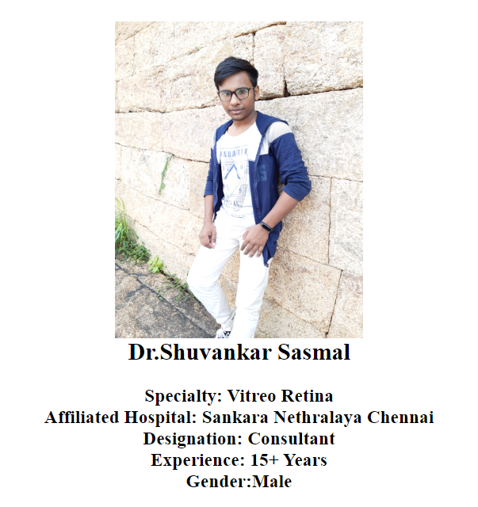 

**CODE FOR PATIENT CORNER**

<html>

<head><title>Mamun=PC</title></head>

<center>

<br><br><h1><mark><U>

Patient Corner.....</mark></U></h1>

<body background="doctor-using-tablet-diagnose-medical-technology.jpg"><br><h3>

<script language="javascript">

function validate()

{

var flag=1;

if(document.myform.id.value==""||

document.myform.title.value==""||

document.myform.no.value==""||

document.myform.cost.value=="")

{

flag=0;

}

str=document.myform.title.value;

var str1=document.myform.cost.value;

if(!((str=="c"&& str1==444) || (str=="jsp" && str1==555)))

{

flag=0;

}

if(flag==1)

{

alert("VALID INPUT");

}

else

{

alert("INVALID INPUT");

document.myform.focus();

}

}

</script>

<form name="myform" action="file:///C:/Users/MD%20AL%20MAMUN/Desktop/Apollo%20Hospital/9%20Age%20Calculator/Age%20Calculator.html" target="right">

<div align="center"><pre>

LOGIN ID :<input type="text" name="id"><br>

Password :<input type="text" name="title"><br>

Passport NO :<input type="text" name="no"><br>

Appionment Date :<input type="text"name="cost"><br>

</pre>

</div>

<div align="center">

<input type="submit" value="ok" onClick="validate()"> &nbsp;&nbsp;&nbsp;&nbsp;

<input type="reset" value="clear">

</form>

</h3>

<a href="file:///C:/Users/MD%20AL%20MAMUN/Desktop/Apollo%20Hospital/1%20Home/1-%20HOME.html">

<font color="black"><B>BACK</B></font></a>

<>

<a href="file:///C:/Users/MD%20AL%20MAMUN/Desktop/Apollo%20Hospital/1%20Home/1-%20HOME.html">

<font color="black"><B>HOME</B></font></a>

</body>

</center>

</html>

**INPUT:**



**OUTPUT:**



**CODE FOR RTC**

<html>

<head><title>Mamun=rct</title></head>

<center>

<br><br><h1><mark><U>

Registration For Covid Test.....</mark></U></h1><frem>

<body bgcolo="white"><br><h3>

<script language="javascript">

function validate()

{

var flag=1;

if(document.myform.id.value==""||

document.myform.title.value==""||

document.myform.no.value==""||

document.myform.cost.value=="")

{

flag=0;

}

str=document.myform.title.value;

var str1=document.myform.cost.value;

if(!((str=="c"&& str1==444) || (str=="jsp" && str1==555)))

{

flag=0;

}

if(flag==1)

{

alert("VALID INPUT");

}

else

{

alert("INVALID INPUT");

document.myform.focus();

}

}

</script>

<form name="myform" action="file:///C:/Users/MD%20AL%20MAMUN/Desktop/Apollo%20Hospital/9%20Age%20Calculator/Age%20Calculator.html" target="right">

<div align="center"><pre>

LOGIN ID :<input type="text" name="id"><br>

Patient NAME :<input type="text" name="title"><br>

Present Address :<input type="text"name="title"><br>

Permanent Address :<input type="text"name="title"><br>

Passport NO :<input type="text" name="no"><br>

Samble Date :<input type="text"name="no"><br>

</pre>

</div>

<div align="center">

<input type="submit" value="ok" onClick="validate()"> &nbsp;&nbsp;&nbsp;&nbsp;

<input type="reset" value="clear">

</form></frem>

</h3>

<a href="file:///C:/Users/MD%20AL%20MAMUN/Desktop/Apollo%20Hospital/1%20Home/1-%20HOME.html">

<font color="black"><B>BACK</B></font></a>

<>

<a href="file:///C:/Users/MD%20AL%20MAMUN/Desktop/Apollo%20Hospital/1%20Home/1-%20HOME.html">

<font color="black"><B>HOME</B></font></a>

</body>

</center>

</html>

**INPUT:**

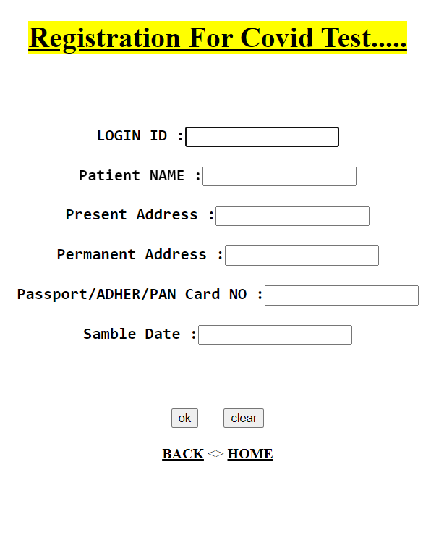

**OUTPUT:**

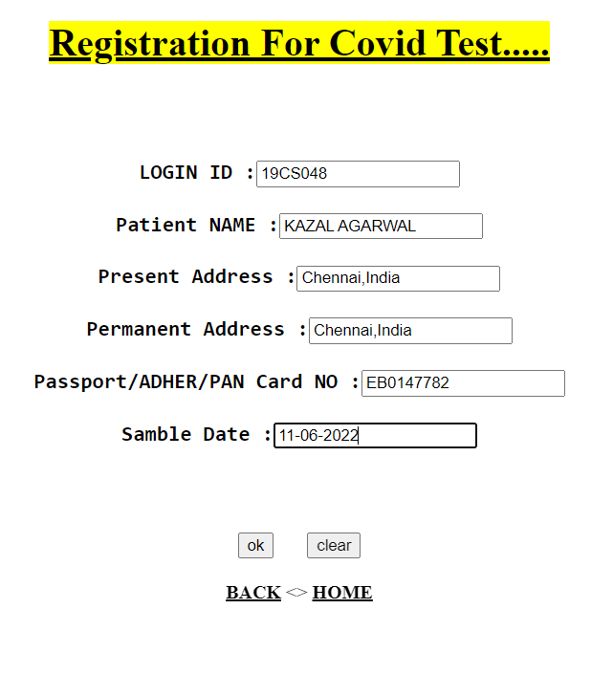

**CODE FOR AGE CALCULATOR:**

<!DOCTYPE html>

<html>

<head>

<title>Mamun=Age Calculator</title>

<style media="screen">

body{

font-family: Arial, Helvetica, sans-serif;

font-size: 15px;

line-height: 1.5;

padding: 0;

margin: 0;

}

* {

box-sizing: border-box;

}

.container{

width:520px;

height: auto;

margin: 100px auto;

background-color: #eee;

border-radius: 5px;

}

.base{

width: 100%;

margin: 0;

overflow: hidden;

display: block;

float: none;

}

.block{

width: 135px;

padding: 5px 20px;

margin-left: 20px;

display: inline-block;

float: left;

}

.base h4{

font-size: 26px;

text-align: center;

font-family: sans-serif;

font-weight: normal;

margin-top: 0px;

box-shadow: 0px 2px #bababa;

background: white;

font-size: 34px;

color: navy;

}

.title{

font-size: 20px;

text-align: left;

font-family: sans-serif;

font-weight: normal;

line-height: 0.5;

letter-spacing: 0.5px;

word-spacing: 2.7px;

color: #1073d0;

}

input[type=text] {

width: 140px;

margin: auto;

outline: none;

min-height: 50px;

border: 2px solid #1073d0;

padding: 12px;

background-color: #f7f7f7;

border-radius: 2px;

color: #1073d0;

font-size: 17px;

}

input[type=text]:focus{

background-color: #ffffff;

border: 2px solid orange;

outline: none;

}

input[type=button]{

width: 150px;

margin-left: 35%;

margin-top: 40px;

outline: none;

border: none;

border-radius: 2px;

background-color: #0761b6;

color: #ffffff;

padding: 14px 16px;

text-align: center;

font-size: 16px;

}

input[type=button]:hover{

background-color: #003669;

}

#age{

display: block;

margin: 10px;

margin-top: 35px;

padding: 10px;

padding-bottom: 20px;

overflow: hidden;

font-family: verdana;

font-size: 23px;

font-weight: normal;

line-height: 1.5;

word-spacing: 2.7px;

color: navy;

}

</style>

</head>

<body background="world-diabetes-day-docter-holding-stethoscope-red-heart-wooden-shape.jpg" height;width="50%">

<div class="container">

<form>

<div class="base">

<div class="enter">

<h4><mark><q><b>Age Calculator</b></q></mark></h4>

</div>

<div class="block">

<p class="title">Date</p>

<input type="text" name="date" id="date" placeholder="dd" required="required" minlength="1" maxlength="2" />

</div>

<div class="block">

<p class="title">Month</p>

<input type="text" name="month" id="month" placeholder="mm" required="required" minlength="1" maxlength="2" />

</div>

<div class="block">

<p class="title">Year</p>

<input type="text" name="year" id="year" placeholder="yyyy" required="required" minlength="4" maxlength="4" />

</div>

</div>

<div class="base">

<div class="enter">

<input type="button" name="submit" value="Submit" onclick="age()" />

</div>

</div>

<div id="age"></div>

</form>

</div>

<script type="text/javascript">

function age() {

var d1 = document.getElementById('date').value;

var m1 = document.getElementById('month').value;

var y1 = document.getElementById('year').value;

var date = new Date();

var d2 = date.getDate();

var m2 = 1 + date.getMonth();

var y2 = date.getFullYear();

var month = [31, 28, 31, 30, 31, 30, 31, 31, 30, 31, 30, 31];

if(d1 > d2){

d2 = d2 + month[m2 - 1];

m2 = m2 - 1;

}

if(m1 > m2){

m2 = m2 + 12;

y2 = y2 - 1;

}

var d = d2 - d1;

var m = m2 - m1;

var y = y2 - y1;

document.getElementById('age').innerHTML = 'Your Age is '+y+' Years '+m+' Months '+d+' Days';

}

</script>

<h2><center><mark>Don't worry You will get married Next year......<mark></h2>

<h2 align="center" font color="black"><u> Powered By::</u>

<h3 align="center" >

Md Al Mamun <br>

Mohana Priya <br>

DhanaLakshimi<br>

Rubiga Sri S.<br>

<br>

<a href="file:///C:/Users/MD%20AL%20MAMUN/Desktop/Apollo%20Hospital/1%20Home/1-%20HOME.html">

<font color="black"><B>BACK</B></font></a>

<>

<a href="file:///C:/Users/MD%20AL%20MAMUN/Desktop/Apollo%20Hospital/1%20Home/1-%20HOME.html">

<font color="black"><B>HOME</B></font></a>

</center>

</h3>

<body>

<html>

**INPUT:**

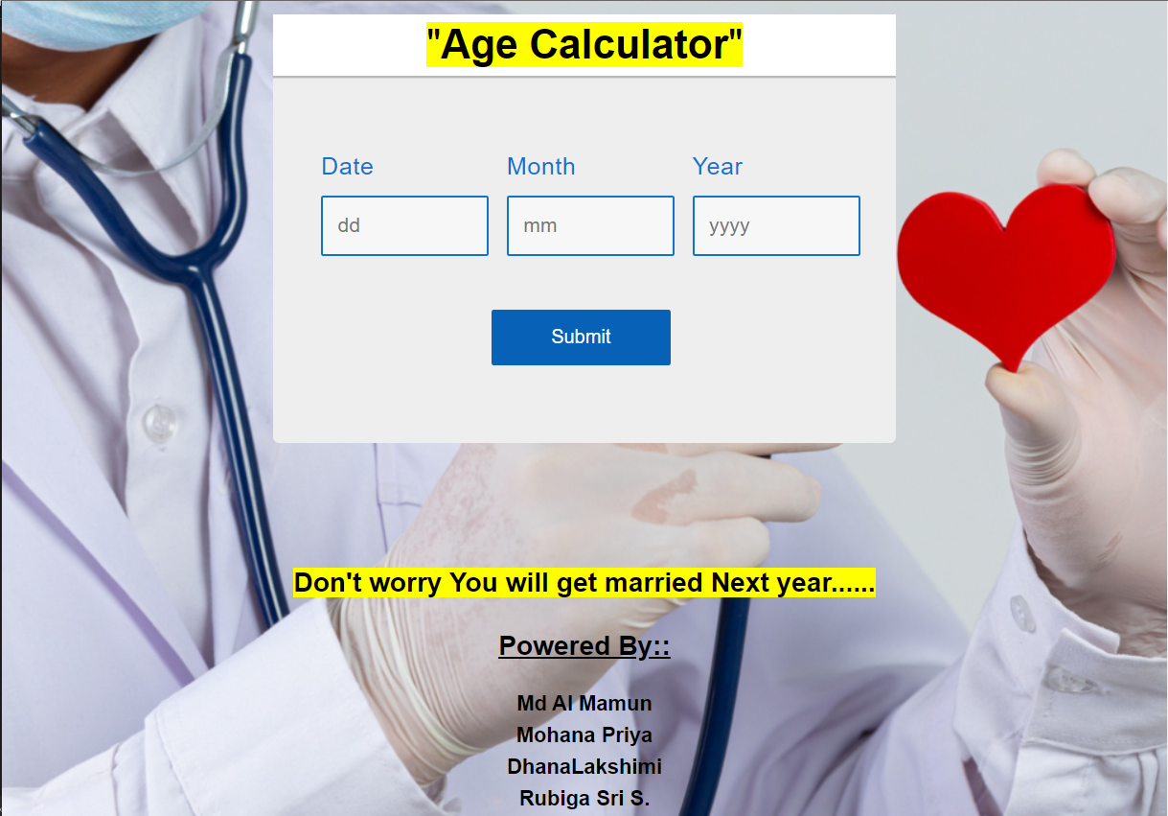

**OUTPUT:**

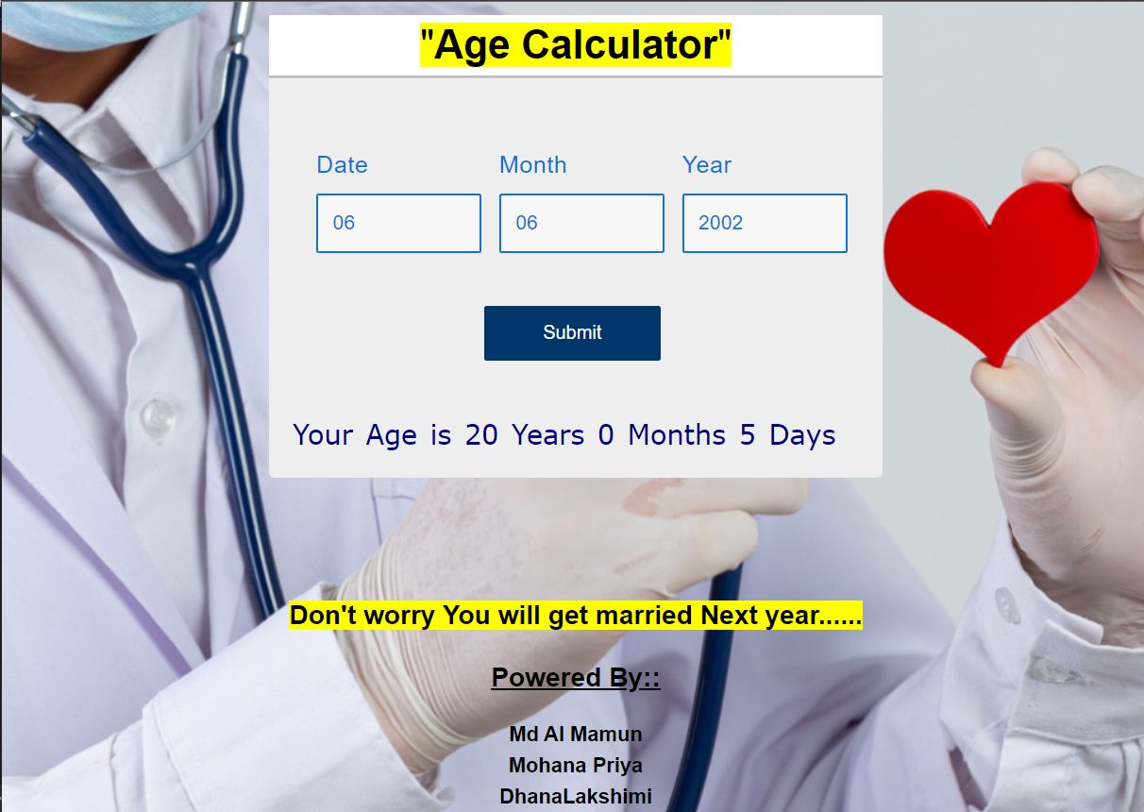

**CODE FOR BMI TEST**

<!DOCTYPE html>

<html lang="en">

<head>

<title>BMI Calculator</title>

<!--Google Font-->

<link rel="preconnect" href="https://fonts.gstatic.com">

<link href="https://fonts.googleapis.com/css2?family=Poppins:wght@500;700&display=swap" rel="stylesheet">

<!--Stylesheet-->

<style media="screen">

*,

*:before,

*:after{

padding: 0;

margin: 0;

box-sizing: border-box;

}

body{

height: 100vh;

background: #046db9;

}

.container{

background-color: #ffffff;

padding: 30px 30px;

width: 400px;

position: absolute;

transform: translate(-50%,-50%);

top: 50%;

left: 50%;

border-radius: 5px;

font-family: 'Poppins',sans-serif;

box-shadow: 25px 25px 30px rgba(0,0,0,0.15);

}

.container h1{

background: #024b94;

color: white;

text-align: center;

font-size: 23px;

letter-spacing: 1px;

margin-top: -30px;

margin-left: -30px;

margin-right: -30px;

margin-bottom: 40px;

}

.row{

display: flex;

align-items: center;

justify-content: space-between;

margin-bottom: 40px;

}

.row span{

font-weight: 500;

}

input[type="range"]{

width: 70%;

height: 3.5px;

-webkit-appearance: none;

appearance: none;

background-color: #dcdcdc;

border-radius: 3px;

outline: none;

}

input[type="range"]::-webkit-slider-thumb{

-webkit-appearance: none;

appearance: none;

height: 15px;

width: 15px;

background-color: #1c1c1c;

border-radius: 50%;

cursor: pointer;

}

#result{

font-size: 30px;

font-weight: 700;

letter-spacing: 1px;

text-align: center;

color: #0be881;

}

#category{

font-size: 18px;

text-align: center;

letter-spacing: 1px;

}

.display{

box-shadow: 0 0 20px rgba(0,139,253,0.25);

margin-bottom: 60px;

}

</style>

</head>

<body>

<div class="container">

<h1>BMI Calculator</h1>

<div class="display">

<p id="result">20.0</p>

<p id="category">Normal weight</p>

</div>

<div class="row">

<input type="range" min="20" max="200" value="20" id="weight" oninput="calculate()">

<span id="weight-val">20 kg</span>

</div>

<div class="row">

<input type="range" min="100" max="250" value="100" id="height" oninput="calculate()">

<span id="height-val">100 cm</span>

</div>

</div>

<!--Script-->

<script type="text/javascript">

function calculate(){

var bmi;

var result = document.getElementById("result");

var weight = parseInt(document.getElementById("weight").value);

document.getElementById("weight-val").textContent = weight + " kg";

var height = parseInt(document.getElementById("height").value);

document.getElementById("height-val").textContent = height + " cm";

bmi = (weight / Math.pow( (height/100), 2 )).toFixed(1);

result.textContent = bmi;

if(bmi < 18.5){

category = "Underweight 😒";

result.style.color = "#ffc44d";

}

else if( bmi >= 18.5 && bmi <= 24.9 ){

category = "Normal Weight 😍";

result.style.color = "#0be881";

}

else if( bmi >= 25 && bmi <= 29.9 ){

category = "Overweight 😮";

result.style.color = "#ff884d";

}

else{

category = "Obese 😱";

result.style.color = "#ff5e57";

}

document.getElementById("category").textContent = category;

}

</script>

</center>

</body>

</html>

<html>

<body>

<h1 align="center"><u><font color="white"> Powered By::</font></u></h1 >

<h3 align="center" ><font color="white">

Md Al Mamun <br>

Mohana Priya <br>

DhanaLakshimi<br>

Rubiga Sri S.</font></h3>

</body>

</html>

**INPUT:**

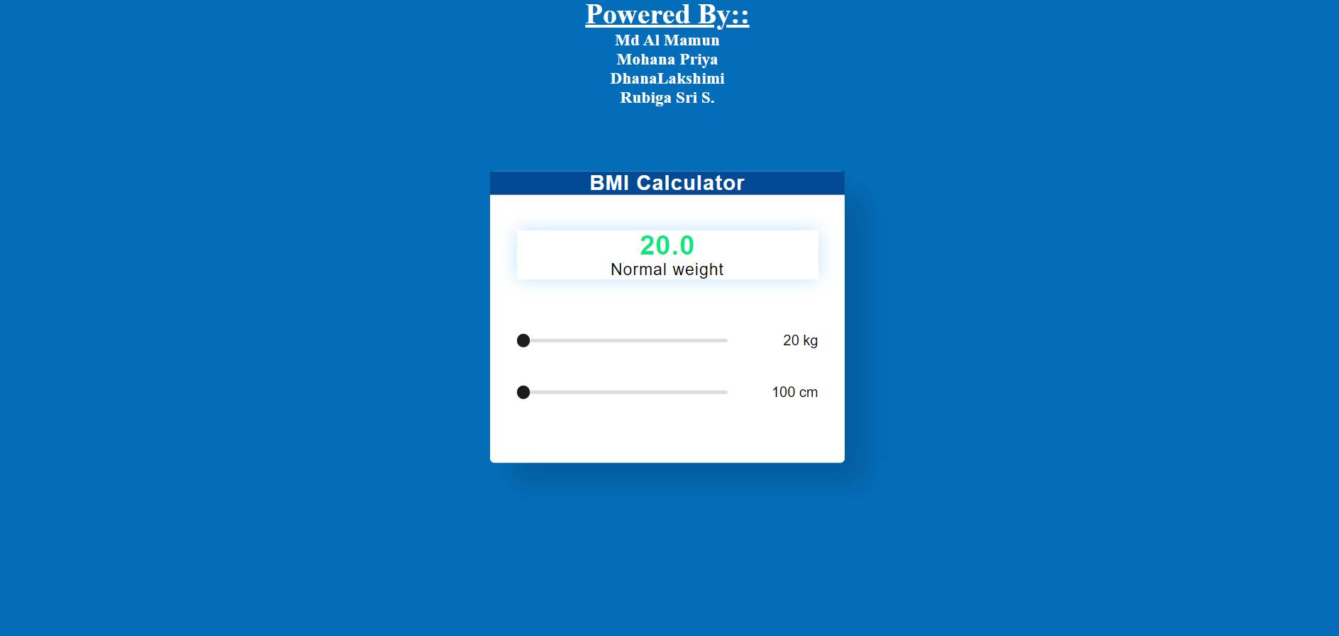

**OUTPUT:**

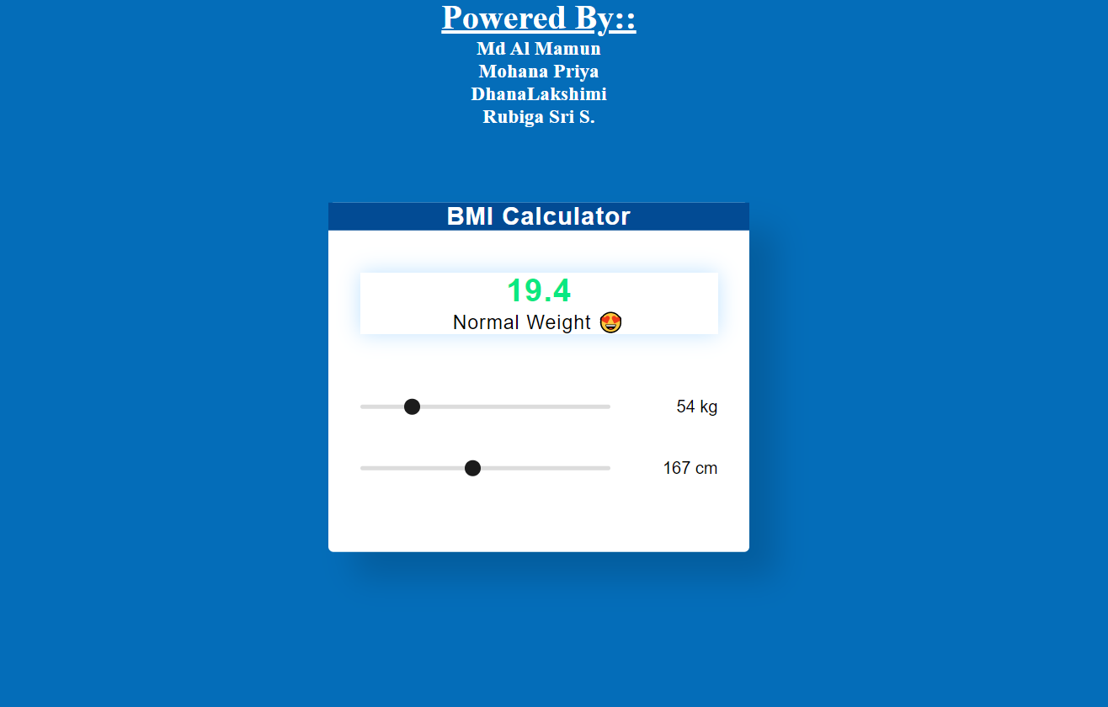

**CODE FOR CONTAC WITH US**

<!DOCTYPE html>

<html>

<head>

<title>Mamun=Age Calculator</title>

<style media="screen">

body{

font-family: Arial, Helvetica, sans-serif;

font-size: 15px;

line-height: 1.5;

padding: 0;

margin: 0;

}

* {

box-sizing: border-box;

}

.container{

width:520px;

height: auto;

margin: 100px auto;

background-color: #eee;

border-radius: 5px;

}

.base{

width: 100%;

margin: 0;

overflow: hidden;

display: block;

float: none;

}

.block{

width: 135px;

padding: 5px 20px;

margin-left: 20px;

display: inline-block;

float: left;

}

.base h4{

font-size: 26px;

text-align: center;

font-family: sans-serif;

font-weight: normal;

margin-top: 0px;

box-shadow: 0px 2px #bababa;

background: white;

font-size: 34px;

color: navy;

}

.title{

font-size: 20px;

text-align: left;

font-family: sans-serif;

font-weight: normal;

line-height: 0.5;

letter-spacing: 0.5px;

word-spacing: 2.7px;

color: #1073d0;

}

input[type=text] {

width: 140px;

margin: auto;

outline: none;

min-height: 50px;

border: 2px solid #1073d0;

padding: 12px;

background-color: #f7f7f7;

border-radius: 2px;

color: #1073d0;

font-size: 17px;

}

input[type=text]:focus{

background-color: #ffffff;

border: 2px solid orange;

outline: none;

}

input[type=button]{

width: 150px;

margin-left: 35%;

margin-top: 40px;

outline: none;

border: none;

border-radius: 2px;

background-color: #0761b6;

color: #ffffff;

padding: 14px 16px;

text-align: center;

font-size: 16px;

}

input[type=button]:hover{

background-color: #003669;

}

#age{

display: block;

margin: 10px;

margin-top: 35px;

padding: 10px;

padding-bottom: 20px;

overflow: hidden;

font-family: verdana;

font-size: 23px;

font-weight: normal;

line-height: 1.5;

word-spacing: 2.7px;

color: navy;

}

</style>

</head>

<body background="world-diabetes-day-docter-holding-stethoscope-red-heart-wooden-shape.jpg" height;width="50%">

<div class="container">

<form>

<div class="base">

<div class="enter">

<h4><mark><q>Age Calculator</q></mark></h4>

</div>

<div class="block">

<p class="title">Date</p>

<input type="text" name="date" id="date" placeholder="dd" required="required" minlength="1" maxlength="2" />

</div>

<div class="block">

<p class="title">Month</p>

<input type="text" name="month" id="month" placeholder="mm" required="required" minlength="1" maxlength="2" />

</div>

<div class="block">

<p class="title">Year</p>

<input type="text" name="year" id="year" placeholder="yyyy" required="required" minlength="4" maxlength="4" />

</div>

</div>

<div class="base">

<div class="enter">

<input type="button" name="submit" value="Submit" onclick="age()" />

</div>

</div>

<div id="age"></div>

</form>

</div>

<script type="text/javascript">

function age() {

var d1 = document.getElementById('date').value;

var m1 = document.getElementById('month').value;

var y1 = document.getElementById('year').value;

var date = new Date();

var d2 = date.getDate();

var m2 = 1 + date.getMonth();

var y2 = date.getFullYear();

var month = [31, 28, 31, 30, 31, 30, 31, 31, 30, 31, 30, 31];

if(d1 > d2){

d2 = d2 + month[m2 - 1];

m2 = m2 - 1;

}

if(m1 > m2){

m2 = m2 + 12;

y2 = y2 - 1;

}

var d = d2 - d1;

var m = m2 - m1;

var y = y2 - y1;

document.getElementById('age').innerHTML = 'Your Age is '+y+' Years '+m+' Months '+d+' Days';

}

</script>

<h2><center>Don't worry You will get married Next year......</h2>

<h2 align="center" font color="black"><u> Powered By::</u>

<h3 align="center" >

Md Al Mamun <br>

Mohana Priya <br>

DhanaLakshimi<br>

Rubiga Sri S.<br>

<br>

<a href="file:///C:/Users/MD%20AL%20MAMUN/Desktop/Apollo%20Hospital/1%20Home/1-%20HOME.html">

<font color="black"><B>BACK</B></font></a>

<>

<a href="file:///C:/Users/MD%20AL%20MAMUN/Desktop/Apollo%20Hospital/1%20Home/1-%20HOME.html">

<font color="black"><B>HOME</B></font></a>

</center>

</h3>

<body>

<html>

**PUBLIC VIEW:**

